**Week 3(Spring Core and Maven)**

**Exercise 1: Configuring a Basic Spring Application**

**//pom.xml**

<project xmlns="http://maven.apache.org/POM/4.0.0"

xmlns:xsi="http://www.w3.org/2001/XMLSchema-instance"

xsi:schemaLocation="http://maven.apache.org/POM/4.0.0

http://maven.apache.org/xsd/maven-4.0.0.xsd">

<modelVersion>4.0.0</modelVersion>

<groupId>com.library</groupId>

<artifactId>LibraryManagement</artifactId>

<version>1.0-SNAPSHOT</version>

<dependencies>

<!-- Spring Core Dependency -->

<dependency>

<groupId>org.springframework</groupId>

<artifactId>spring-context</artifactId>

<version>5.3.34</version>

</dependency>

</dependencies>

<build>

<plugins>

<!-- Plugin to run the main class -->

<plugin>

<groupId>org.codehaus.mojo</groupId>

<artifactId>exec-maven-plugin</artifactId>

<version>3.1.0</version>

<configuration>

<mainClass>com.library.MainApp</mainClass>

</configuration>

</plugin>

</plugins>

</build>

</project>

**// -- src/main/resources/applicationContext.xml:**

**// --applicationContext.xml**

<?xml version="1.0" encoding="UTF-8"?>

<beans xmlns="http://www.springframework.org/schema/beans"

xmlns:xsi="http://www.w3.org/2001/XMLSchema-instance"

xsi:schemaLocation="http://www.springframework.org/schema/beans

http://www.springframework.org/schema/beans/spring-beans.xsd">

<bean id="bookRepository" class="com.library.repository.BookRepository" />

<bean id="bookService" class="com.library.service.BookService">

<property name="bookRepository" ref="bookRepository" />

</bean>

</beans>

**Path: src/main/java/com/library/repository/BookRepository.java**

package com.library.repository;

public class BookRepository {

public void saveBook(String bookName) {

System.out.println("Saving book: " + bookName);

}

}

**Path: src/main/java/com/library/service/BookService.java**

package com.library.service;

import com.library.repository.BookRepository;

public class BookService {

private BookRepository bookRepository;

// Setter for dependency injection

public void setBookRepository(BookRepository bookRepository) {

this.bookRepository = bookRepository;

}

public void addBook(String bookName) {

System.out.println("Adding book: " + bookName);

bookRepository.saveBook(bookName);

}

}

**Path: src/main/java/com/library/MainApp.java**

package com.library;

import com.library.service.BookService;

import org.springframework.context.ApplicationContext;

import org.springframework.context.support.ClassPathXmlApplicationContext;

public class MainApp {

public static void main(String[] args) {

ApplicationContext context = new ClassPathXmlApplicationContext("applicationContext.xml");

BookService bookService = (BookService) context.getBean("bookService");

bookService.addBook("The Alchemist");

}

}

**Output:**

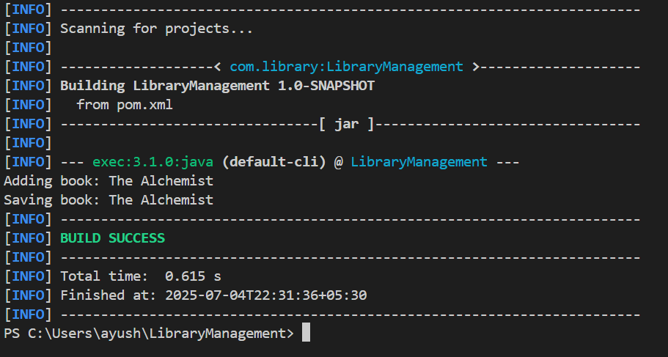

**Exercise 2: Implementing Dependency Injection**

**applicationContext.xml**

<?xml version="1.0" encoding="UTF-8"?>

<beans xmlns="http://www.springframework.org/schema/beans"

xmlns:xsi="http://www.w3.org/2001/XMLSchema-instance"

xsi:schemaLocation="http://www.springframework.org/schema/beans

http://www.springframework.org/schema/beans/spring-beans.xsd">

<!-- Define BookRepository bean -->

<bean id="bookRepository" class="com.library.repository.BookRepository" />

<!-- Define BookService bean and inject BookRepository using setter -->

<bean id="bookService" class="com.library.service.BookService">

<property name="bookRepository" ref="bookRepository" />

</bean>

</beans>

**src/main/java/com/library/service/BookService.java**

package com.library.service;

import com.library.repository.BookRepository;

public class BookService {

private BookRepository bookRepository;

// Setter method for dependency injection

public void setBookRepository(BookRepository bookRepository) {

this.bookRepository = bookRepository;

}

public void addBook(String bookName) {

System.out.println("Adding book: " + bookName);

bookRepository.saveBook(bookName);

}

}

**src/main/java/com/library/MainApp.java**

package com.library;

import com.library.service.BookService;

import org.springframework.context.ApplicationContext;

import org.springframework.context.support.ClassPathXmlApplicationContext;

public class MainApp {

public static void main(String[] args) {

// Load Spring container from XML config

ApplicationContext context = new ClassPathXmlApplicationContext("applicationContext.xml");

// Retrieve the bookService bean

BookService bookService = (BookService) context.getBean("bookService");

// Use the service

bookService.addBook("The Alchemist");

}

}

**Output** :

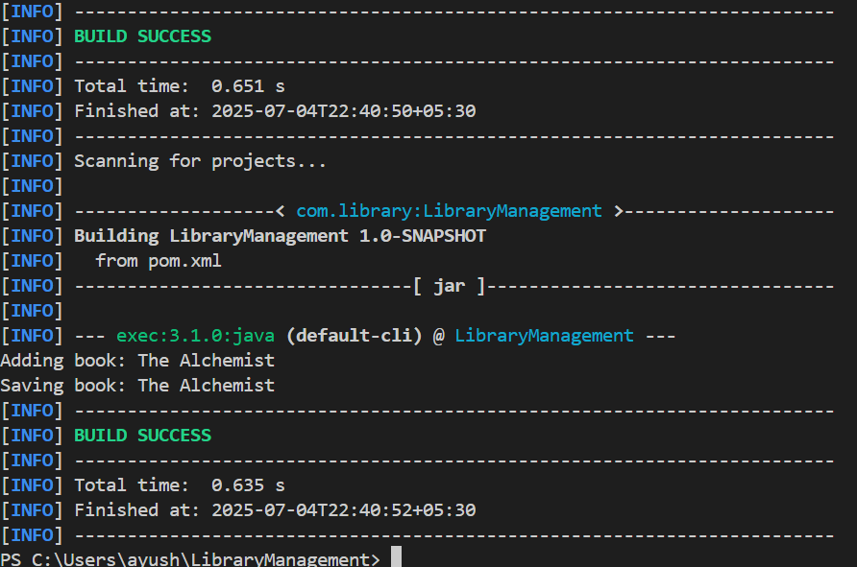

**Exercise 4: Creating and Configuring a Maven Project**

**File structure**

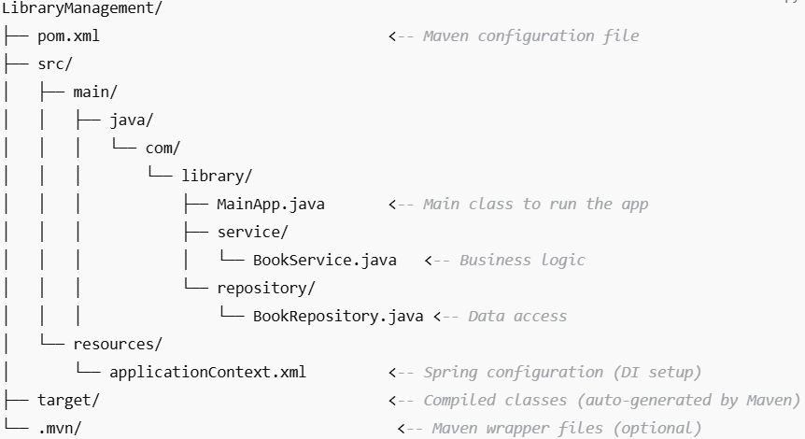

**//pom.xml**

<project xmlns="http://maven.apache.org/POM/4.0.0"

         xmlns:xsi="http://www.w3.org/2001/XMLSchema-instance"

         xsi:schemaLocation="http://maven.apache.org/POM/4.0.0

                             http://maven.apache.org/xsd/maven-4.0.0.xsd">

    <modelVersion>4.0.0</modelVersion>

    <groupId>com.library</groupId>

    <artifactId>LibraryManagement</artifactId>

    <version>1.0-SNAPSHOT</version>

    <dependencies>

        <!-- Spring Core / Context -->

        <dependency>

            <groupId>org.springframework</groupId>

            <artifactId>spring-context</artifactId>

            <version>5.3.34</version>

        </dependency>

        <!-- Spring AOP -->

        <dependency>

            <groupId>org.springframework</groupId>

            <artifactId>spring-aop</artifactId>

            <version>5.3.34</version>

        </dependency>

        <!-- Spring Web MVC -->

        <dependency>

            <groupId>org.springframework</groupId>

            <artifactId>spring-webmvc</artifactId>

            <version>5.3.34</version>

        </dependency>

        <!-- Servlet API (for Web MVC to compile) -->

        <dependency>

            <groupId>javax.servlet</groupId>

            <artifactId>javax.servlet-api</artifactId>

            <version>4.0.1</version>

            <scope>provided</scope>

        </dependency>

    </dependencies>

    <build>

        <plugins>

            <!-- Maven Compiler Plugin -->

            <plugin>

                <groupId>org.apache.maven.plugins</groupId>

                <artifactId>maven-compiler-plugin</artifactId>

                <version>3.11.0</version>

                <configuration>

                    <source>1.8</source>

                    <target>1.8</target>

                </configuration>

            </plugin>

            <!-- Exec Plugin to run main class (optional) -->

            <plugin>

                <groupId>org.codehaus.mojo</groupId>

                <artifactId>exec-maven-plugin</artifactId>

                <version>3.1.0</version>

                <configuration>

                    <mainClass>com.library.MainApp</mainClass>

                </configuration>

            </plugin>

        </plugins>

    </build>

</project>

**Output:**

